EXERCISE 4: FUNCTIONS
Scenario 1: Calculate Customer Age
Question:
Write a function CalculateAge that accepts a customer's date of birth (DOB) and returns the customer's age in years.
Code
CREATE OR REPLACE FUNCTION CalculateAge(
p_dob DATE
)
RETURN NUMBER
IS
BEGIN
RETURN FLOOR(
MONTHS_BETWEEN(SYSDATE, p_dob) / 12
);
END;
/
Execution
SELECT CustomerID,
Name,
CalculateAge(DOB) AS Age
FROM Customers;
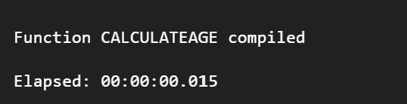
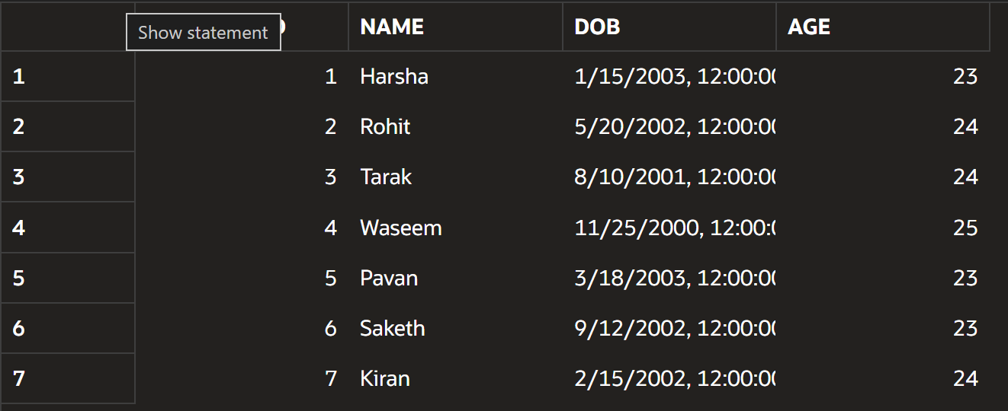

Scenario 2: Calculate Monthly Loan Installment
Question:
Write a function CalculateMonthlyInstallment that calculates and returns the monthly installment amount based on the loan amount, annual interest rate, and loan duration in years.
Code
CREATE OR REPLACE FUNCTION CalculateMonthlyInstallment(
p_amount NUMBER,
p_rate NUMBER,
p_years NUMBER
)
RETURN NUMBER
IS
v_months NUMBER;
BEGIN
v_months := p_years * 12;

RETURN
(
p_amount +
(p_amount * p_rate * p_years / 100)
) / v_months;
END;
/
Execution
SELECT CalculateMonthlyInstallment(50000,5,5)
AS Monthly_Installment
FROM DUAL;
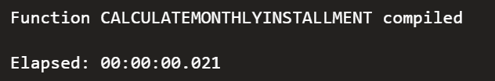
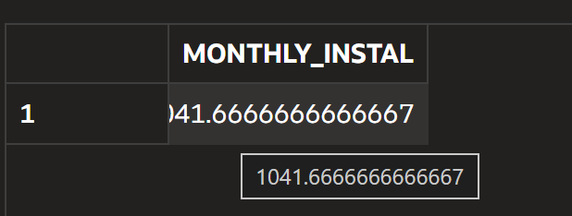

Scenario 3: Check Account Balance
Question:
Write a function HasSufficientBalance that accepts an Account ID and a withdrawal amount, then returns TRUE if the account has sufficient balance; otherwise, it returns FALSE.
Code
CREATE OR REPLACE FUNCTION HasSufficientBalance(
p_account NUMBER,
p_amount NUMBER
)
RETURN VARCHAR2
IS
v_balance NUMBER;
BEGIN
SELECT Balance
INTO v_balance
FROM Accounts
WHERE AccountID = p_account;

IF v_balance >= p_amount THEN
RETURN 'TRUE';
ELSE
RETURN 'FALSE';
END IF;
END;
/
Execution
SELECT HasSufficientBalance(1,500)
AS Balance_Status
FROM DUAL;
